Education and Learning Directorate (Form Bridge INT1 Aug 2023)
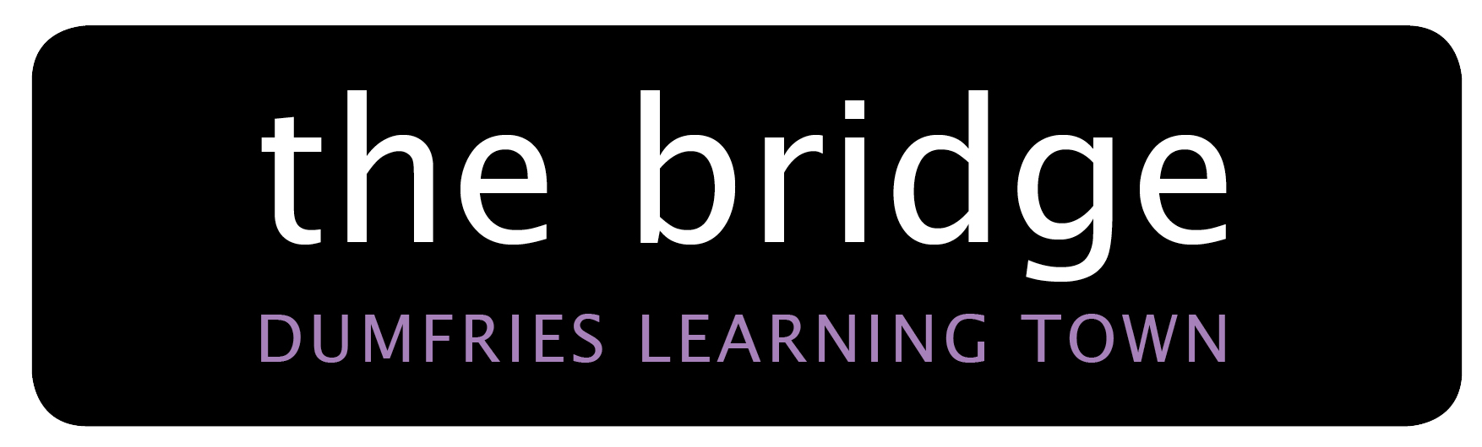
Room Booking Form – Internal

Rooms at the Bridge are available to Let by Council Departments. If you would like to use facilities at the Bridge, please complete the form below. Please note there are no refreshment facilities at the Bridge, however an urn can be supplied for ‘bring your own’.
A charge may be applicable where the Let incurs a cost to the Bridge or there is an exchange of money at the event. If this is the case, you will be notified of the charge prior to confirmation of the booking.

Please return completed form by email to thebridge@dumgal.gov.uk

Department |  |  |  |  |  |  |  |  |  |  | Section
Name of Hirer |  |  |  |  |  |  |  |  |  |  | Designation
Address 1
Address 2 |  |  |  |  |  |  |  |  |  |  | Postcode
Telephone |  |  |  |  |  |  |  |  |  |  | Email
Internal Re-charge Code if appropriate (weekends and out with core hours 08:00 - 20.00)
Event
Lead Contact
Purpose / Nature of Booking
Day |  | Start Date |  |  |  |  |  |  |  | End Date |  |  |  |  |  | Start Time |  |  | End Time
Regular Bookings | Weekly |  |  |  |  |  | Monthly |  |  |  |  |  |  |  | Other
Type of Area requested
Approximate Numbers | U18s / 60+ |  |  |  |  |  |  | Adults |  |  |  |  | Is there an exchange of money to attend? YES / NO  If YES for example, how much  (a) Attendance Ticket – (a) £  (b) Refreshments - (b) £  (c) Raffle Tickets - (c) £  (d) Other - (d) £
Special Requirements / Equipment Required (screens, laptops, urn) / Layout Required / Dates not required / Etc.
Signature of Hirer |  |  |  |  |  |  |  |  |  |  |  | Date

